Sales Analysis Results

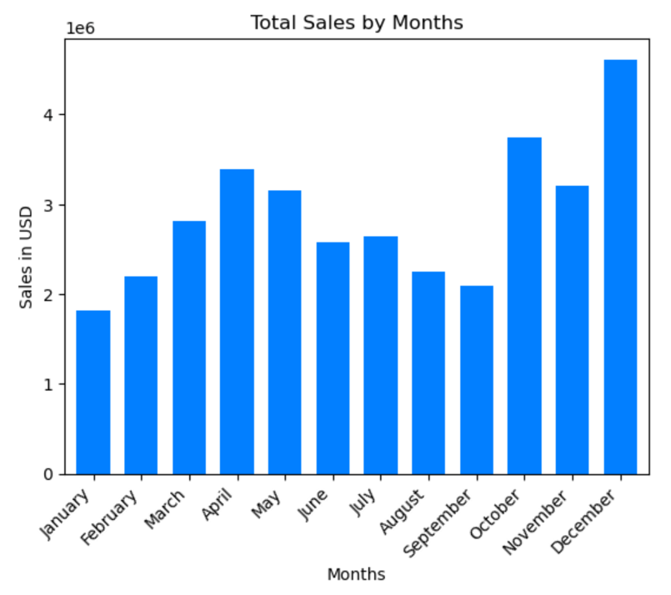Analysis by Month of Purchase

* Highest sales: December
* Lowest sales: January

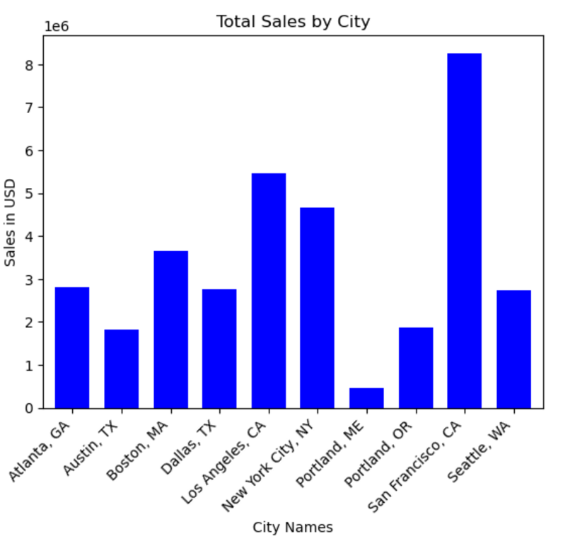

Analysis by City of Purchase

* Highest sales: San Francisco, CA
* Lowest sales: Portland, ME

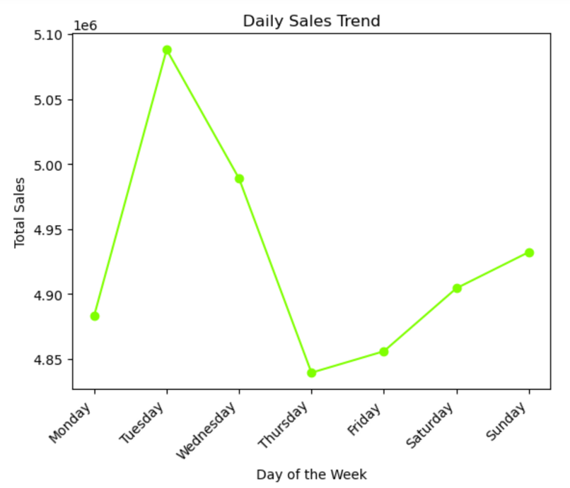Analysis by Day of Purchase

* Highest sales: Tuesday
* Lowest sales: Thursday

Analysis by Hour of Purchase

* Highest sales: 19 pm
* Lowest sales: 3 am
* 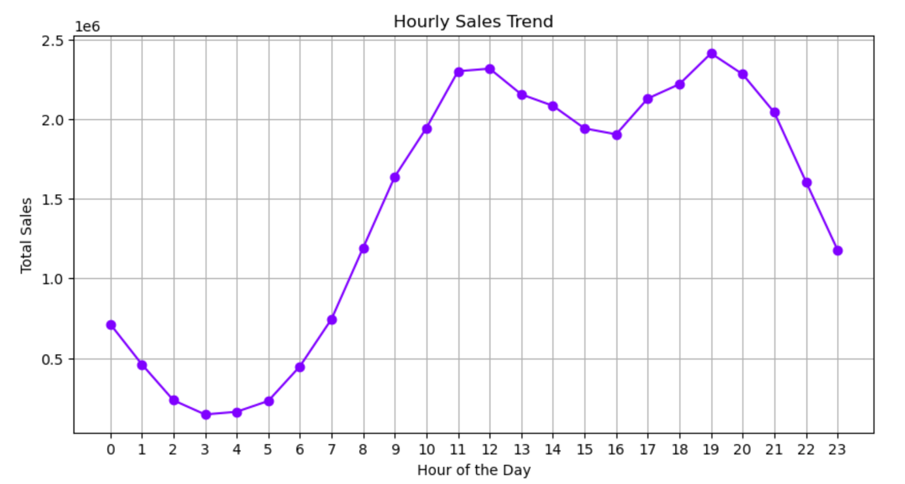

Top 10 product pairs that are purchased together:

|  |  |
| --- | --- |
| iPhone - Lightning Charging Cable | 1005 sales |
| Google Phone - USB-C Charging Cable | 987 sales |
| iPhone - Wired Headphones | 447 sales |
| Google Phone - Wired Headphones | 414 sales |
| Vareebadd Phone - USB-C Charging Cable | 361 sales |
| iPhone - Apple Airpods Headphones | 360 sales |
| Google Phone - Bose SoundSport Headphones | 220 sales |
| Vareebadd Phone - Wired Headphones | 143 sales |
| USB-C Charging Cable - Wired Headphones | 120 sales |
| Vareebadd Phone - Bose SoundSport Headphones | 80 sales |

Order quantities of products (sorted)

|  |  |
| --- | --- |
| Product | Quantity Ordered |
| AAA Batteries (4-pack) | 31017 |
| AA Batteries (4-pack) | 27635 |
| USB-C Charging Cable | 23975 |
| Lightning Charging Cable | 23217 |
| Wired Headphones | 20557 |
| Apple Airpods Headphones | 15661 |
| Bose SoundSport Headphones | 13457 |
| 27in FHD Monitor | 7550 |
| iPhone | 6849 |
| 27in 4K Gaming Monitor | 6244 |
| 34in Ultrawide Monitor | 6199 |
| Google Phone | 5532 |
| Flatscreen TV | 4819 |
| Macbook Pro Laptop | 4728 |
| ThinkPad Laptop | 4130 |
| 20in Monitor | 4129 |
| Vareebadd Phone | 2068 |
| LG Washing Machine | 666 |
| LG Dryer | 646 |

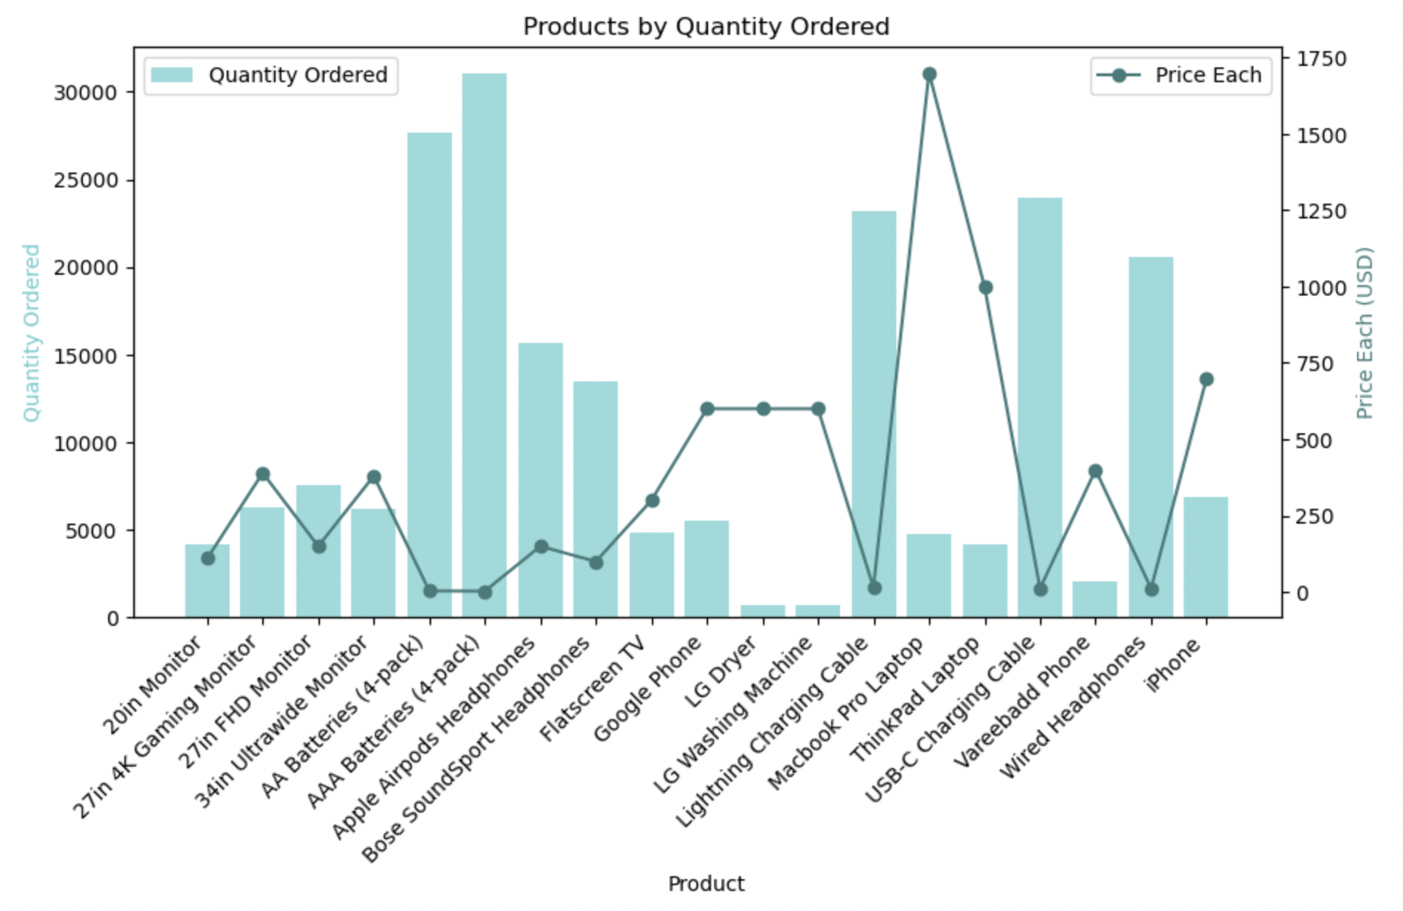Analysis the effect of price

Upon analyzing the relationship between the price of products and their respective quantities ordered, it can be observed that higher-priced products exhibit lower quantities ordered, while lower-priced items tend to witness higher quantities ordered. This observation suggests an inverse relationship between the price and quantity of products sold.